**FALL is in the air! Presenting the programme of this year’s Festival of Art, Literature & Learning at DOX, which features guests such as Alberto Manguel and Max Porter. The unifying theme this year is portrait and self-portrait, fiction and autofiction.**

**Stories, experiences, discovery, sharing. The second edition of the interdisciplinary Festival of Art, Literature & Learning (FALL) at the DOX Centre for Contemporary Art in Prague will run from Thursday, 19 September to Sunday, 22 September, with a programme for schools and educators continuing until 24 September.**

**All of the information about the event can be found at the festival website** [**doxfall.cz**](https://www.doxfall.cz/en/about) **or the Facebook page** [**DOX FALL**](https://www.facebook.com/doxpraguefall)**.**

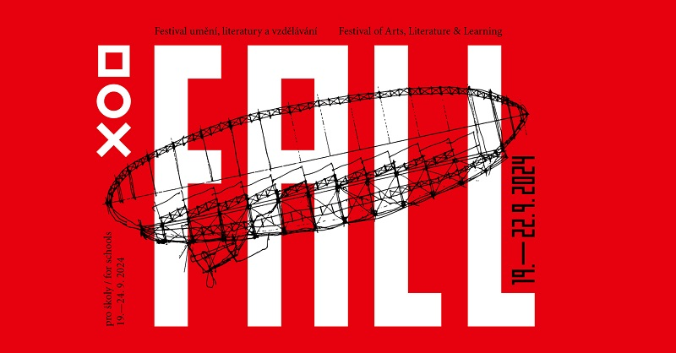

**FESTIVAL GUESTS**

This year, the FALL festival at DOX will once again be hosting a number of literary and artistic figures from the Czech Republic and abroad. Among the local guests will be writers **Marek Torčík**, **Bianca Bellová**, **Alena Machoninová**, **Jan Němec**, and **Daniela Vodáčková**.

The foreign guests will include, for example, the renowned Argentine-Canadian writer and promoter of reading **Alberto Manguel**, who in his youth read to the blind Jorge Luis Borges, or the prominent Turkish artist **Ali Kazma**. The world-famous filmmakers and artists **Timothy and Stephen Quay**, whose sources of inspiration include Jan Švankmajer, Franz Kafka, and Leoš Janáček, will also be present. Visitors can also look forward to **Max Porter**, one of the most original voices of contemporary British prose, as well as **Dimitri Verhulst**, who is among the most distinctive Belgian authors of his generation.

The four-day programme will introduce writers, artists, and other interesting guests from the United Kingdom, Belgium, the United States, Israel, Turkey, Ireland, Italy, and Portugal.

Interested members of the public can register for **special interdisciplinary workshops** led by poet **Petr Borkovec**, painter **Adam Štech**, writer and architect **Anna Beata Háblová**, and Italian photographer **Stefano Carini**.

**Artists and writers you can meet at the FALL festival:**

**Petr Borkovec, Alberto Manguel, Alena Machoninová, Marek Torčík, Max Porter, Jan Němec, the Quay brothers, Bianca Bellová, Benjamin Balint, Ali Kazma, Hynek Martinec, Dimitri Verhulst, Josef Bolf, Anna Beata Háblová, Alice Koubová, Tomáš Koblížek, Adam Štech, Magdaléna Platzová, Stefano Carini, Blanka Činátlová, Petr Vizina, Otto M. Urban,** and others…

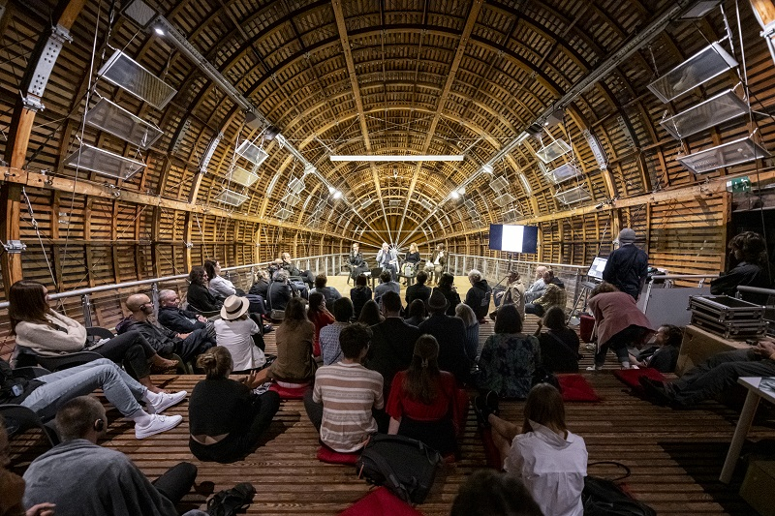

**THEME: PORTRAIT AND SELF-PORTRAIT, FICTION AND AUTOFICTION**

This year the festival will focus on the theme of portrait and self-portrait, fiction and autofiction. Can they be thought of in a similar way? How do we narrate reflections of our own self, and how do we mediate the lives of others? Why are we attracted to authors’ “confessions” which are based in reality, and what does it mean to risk your skin in your writing? And what is the self in a text written by artificial intelligence? How have painterly self-portraits changed in the age of the selfie, and is today’s selfie culture more than a simple manifestation of our obsession with self-presentation? These questions and more will be addressed by the guests of this year’s festival.

“The theme of Empathy in the Digital Age, which kicked off the first year of the FALL festival, remains more relevant than ever, and this year’s theme Portrait / Self-Portrait will build on it further. Guests of the festival include authors of distinctive autofiction novels and writers and artists who truly put themselves on the line in their books or works. However, the programme also features those who have attempted to capture the lives of others in their literary or artistic portraits, detailing the fates of real people, historical or living. Much has been written and said in the past few years about the authenticity or unreliability of literary (auto)biographies, ‘fiction fatigue’, and other related topics. The FALL festival opens the topic in the broader context of multiple artistic genres but also in the context of social issues and aspects of the digital age that affect all of our lives on a daily basis,”explains Michaela Šilpochová, director of the festival and artistic director of DOX.

**FESTIVAL PROGRAMME**

**Over the course of several days, visitors will have the chance to meet Czech and international writers, artists, philosophers, and other interesting individuals. There will be literary discussions, special interdisciplinary workshops led by artists and writers, guided tours of exhibitions with literary overlaps, slam poetry, and musical performances, all on board the Gulliver Airship and throughout the DOX Centre for Contemporary Art. There will also be activities for students and families, and visitors can look forward to film screenings, including the Czech premiere of *The Glory of Life*, a film about the last year of Franz Kafka’s life. The festival will be opened by Max Porter and Alberto Manguel and will conclude with a performance by the BERG Orchestra.**

The festival programme naturally also includes **exhibitions of contemporary art**. This year’s festival will build on the international exhibition *KAFKAesque*, which will be closing soon, as well as an exhibition by Adam Štech inspired by the work of French writer Michel Houellebecq and a solo exhibition by painter Josef Bolf.

**The full programme can be found at:** [doxfall.cz/program](https://www.doxfall.cz/en/programme)

**THURSDAY 19.09**

On Thursday evening, we will have the **Grand Opening of FALL 2024**, featuring several guests of the festival: Max Porter, Alberto Manguel, Marek Torčík, Bianca Bellová, and Dimitri Verhulst. Visitors can look forward to performances, discussions, readings, and even a bonfire.

**FRIDAY 20.09**

On Friday, the programme will begin in the afternoon with a **guided tour of the exhibition *KAFKAesque*** in English, with curators Otto M. Urban, Leoš Válka, and Michaela Šilpochová and a special guest, artist Rowynn Dumont.

This will be followed by the public discussion **The Latest Czech Prose** about the new Literary Criticism Prize. Guests will discuss which of this year’s books are worthy of attention and by what criteria they should actually be judged. Featuring Petr A. Bílek, Kryštof Eder, Jan M. Heller, Marta Ljubková, and Olga Pavlova.

In 2015 Max Porter mesmerised the literary world with his debut novella *Grief Is the Thing with Feathers*. Now you can meet him at the FALL festival on board the Gulliver Airship. The discussion **On the Verge of Words with Max Porter** will be hosted by Petr Vizina.

In the evening, we’ll explore **The Enigmatic Universe of the Quay Brothers**. A conversation between writer and journalist Benjamin Balint and the Quay brothers will be accompanied by a screening of their award-winning short films.

The day will then conclude with poetry as a show. An exhibition set of the top Czech slam poetry, a genre of performative poetry, will focus on the theme of the self-portrait as a verbal selfie. The **Slam Poetry Show** will feature Vašek z Aše, Tim Postovit, and Večerka.

**SATURDAY 21.09**

The weekend mornings will be devoted to four two-day workshops for the public. Poet and writer Per Borkovec will offer a poetry and prose course for 12 people and about 12 things entitled **Still Life with Glass Goblets and Lemon**. Adam Štech, whose latest paintings are currently on display at DOX in the exhibition *houellebecq!*, will host the painting workshop **Selfie vs. Self-Portrait**. Artist and architect Anna Beata Háblová will lead the literary-architectural workshop **Writing from Space**. And the workshop **Visual Storytelling** will focus on photography with Italian visual storytelling expert Stefano Carini.

The lecture **Self-Portrait as the First Sin in Art** by curator and art historian Otto M. Urban will be accompanied by a debate with poet Daniela Vodáčková and artist Hynek Martinec on non-traditional approaches to self-portraiture in contemporary art and poetry.

In the discussion **Reading *houellebecq!***, philosopher Tereza Matějčková, painter Adam Štech, and curator Otto M. Urban will debate how the public image of artists and our awareness of them changes our view of their work. As part of the discussion, which will take place inside the exhibition *houellebecq!*, actor Miloslav König will read excerpts from the French writer’s texts.

In the afternoon, Petr Borkovec invites visitors to a reading of the short true prose text **The Legend of Myself, as Told by My Mother, while Grandma Was Sitting next to Me**, which is characterised by very compelling – particularly visual – links to a lie.

The afternoon programme in the Gulliver Airship will kick off with the discussion **Bruno Schulz: A Writer, an Artist, and the Hijacking of History**, where writer Magdaléna Platzová will discuss the topic with Benjamin Balint, author of a new seminal biography of Bruno Schulz.

Writer, critic, and essayist Alberto Manguel has dedicated his life to promoting the importance of reading. At the FALL festival, he will take part in the discussion **Portrait of a Writer as a Reader** with video artist Ali Kazma, who captured Manguel’s poetic film portrait in his work *Alberto in Lisbon*, which will premiere at the festival that same afternoon. The discussion will be hosted by Petr Vizina.

The evening programme will be dedicated to the Czech premiere of the film ***The Glory of Life***, a surprisingly “un-Kafkaesque” portrayal of the final year of Franz Kafka’s life.

**SUNDAY 22.09**

The four two-day workshops will continue and also conclude on Sunday morning.

In the meantime, the family workshop **Take Nitka on a Walk** will take place in the courtyard. In this open art workshop for children aged five and up, visitors can set off on a little textile adventure.

At 11 o’clock you can look forward to another series of discussions, starting with **The Artist and Artificial Creativity**, which is a debate between philosopher Tomáš Hříbek, artist Josef Bolf, and curator Otto M. Urban inside Bolf’s exhibition *Melancholy of the Outer Limits*, for which the artist has written a new short story in collaboration with artificial intelligence. The story will be read by Michal Kern.

The discussion **Autofiction: Between Empathy and Emancipation** will focus on whether autofiction is purely a manifestation of the emancipatory powers of literature or whether it also holds the promise of empathy and therapy. The guests will also weigh in on what the term autofiction means to them. Blanka Činátlová will host this discussion between Alena Machoninová and Marek Torčík about the limits of (auto)biographical writing and literary memory as well as their own empathy as readers and the different forms of literary authenticity.

The afternoon debate **The Self in the Age of Complexity**, featuring philosophers Alice Koubová and Tomáš Koblížek, focuses on how selfie culture influences us and the difference between the self, the ego, and identity. The discussion will be hosted by writer Anna Beata Háblová.

The evening programme will feature a conversation with the novelist and poet Dimitri Verhulst, whose work depicts the erosion of humanity without sentimentality but with uncompromising clarity and humour. The discussion, entitled **Life and Other Addictions**, will be hosted by Josefína Formanová, and excerpts from the author’s latest book will be read by translator Veronika ter Harmsel Havlíková.

**Goodbye KAFKAesque!** will be the **Grand Finale** of this year’s FALL festival as well as the exhibition *KAFKAesque*. The soloists of the BERG Orchestra will perform Steve Reich’s *Different Trains* and Gideon Lewensohn’s *Odradek*.

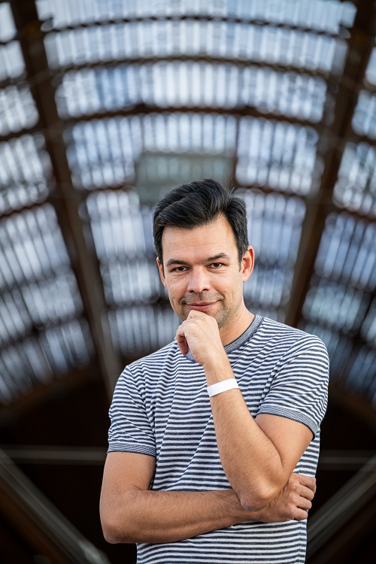**DISCUSSIONS**

The FALL festival is a space for the thoughts and voices of writers, artists, and other creative individuals from various disciplines as well as their inspiring “borderlands”. The main programme will present **both local and international authors and artists, often in dialogue with each other.**

“After the Prague Writers’ Festival ended, for several years the capital city was lacking any kind of sizeable literary festival with international participation. It’s great that the DOX Centre for Contemporary Art is committed to organising one. Alberto Manguel, Dimitri Verhulst, and Benjamin Balint are names that have appeared in the pages of *Host* a number of times, and DOX is also better at connecting them with the Czech literary scene than the Prague Writers’ Festival was,” says Jan Němec, writer, journalist, editor-in-chief of the magazine *Host*, and a regular visitor of the festival.

**EMPATHY IN THE DIGITAL AGE: FALL FOR SCHOOLS AND LIBRARIES**

An important part of the festival consists of programmes for secondary school students and teachers on the topic of **empathy in the digital age**. We have thus prepared a series of discussions with authors and follow-up workshops aimed at developing empathy through sharing personal stories. These workshops are based on the methodology of the international educational project Narrative 4, whose founder, Irish writer Colum McCann, was a guest of the first edition of FALL.

Narrative 4 has been successfully implemented in schools in Ireland and the USA for more than 10 years, where sociological research and studies have proved its effectiveness in practice: fostering empathy by sharing personal stories has been shown to lead to greater levels of understanding and respect among students as well as between students and teachers, while also promoting greater group cohesion, preventing bullying, and more.

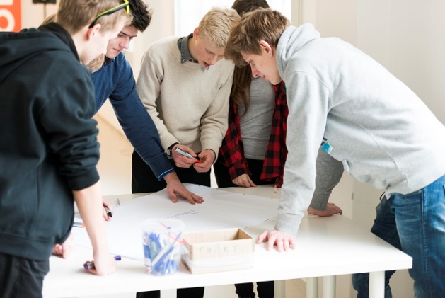

As part of its years of work in the field of creative education, DOX incorporated this methodology into its programme in 2021 and expanded it to include connections to the visual arts and literature. DOX produces over 600 educational programmes a year, focusing not only on empathy but also on the development of critical thinking and social skills. In 2023 more than 12,000 students from Prague and its surroundings participated in educational programmes at DOX. This year the festival will also include a special workshop for educators and lecturers focused on misinformation. More information about the workshop can be found [here](https://www.dox.cz/en/programmes-for-school-groups/the-truth-or-a-lie).

“Education is an absolutely integral part of the festival. The programmes build on a concept that is based around reading stories, sharing, meeting, and fostering empathy. In the programmes for schools, students will have the unique opportunity to meet writers such as Jan Němec, Dimitri Verhulst, Alena Machoninová, and Marek Torčík and discuss how personal stories are reflected in their literary works. After all, literature and the visual arts have the ability to transform individual experience into a shared human experience,” explains Lucie Laitlová, coordinator of DOX’s educational projects.

Something new in this second year of the FALL festival is the participation of library staff from all over the Czech Republic. Narrative 4 has prepared a special presentation for librarians, which will be presented by two of its instructors from Ireland. The presentation and follow-up workshop will focus on introducing the benefits and potential of the Narrative 4 methodology for communities as well as the training opportunities being developed by DOX. More information can be found [here](https://www.doxfall.cz/en/program/empathy-through-story-exchange).

“At a time when we share more on social media than in the real world and our day-to-day lives and relationships have been marred by the recent pandemic, digital technologies, the threat of climate change, the presence of war in Europe, and the uncertainty brought on by the rapid rise of artificial intelligence, the FALL festival is an opportunity to slow down, listen, and share. To see the world through someone else’s eyes for a moment, to enter into someone else’s story. To ask if creativity, imagination, and empathy are what (at least for now) set us apart from our artificially intelligent future,” says Michaela Šilpochová.

**WHERE THE FESTIVAL TAKES PLACE**

The DOX Centre for Contemporary Art was created through a private initiative by converting a former factory in Prague’s Holešovice neighbourhood. It is the Czech Republic’s largest non-profit, non-governmental institution dedicated to contemporary art. Since 2008 its mission has been to foster an environment for the exploration, discussion, and artistic presentation of important social issues, where art, literature, music, theatre, and other disciplines enable a critical approach to the so-called reality of today’s world. The exhibition area of more than 3000 m2 is complemented by the DOX+ Multifunctional Hall, the Gulliver Airship, the Fine Art Archive, the Bendox Bookstore, and the design shop DOX by Qubus.

The heart of the FALL festival is the **Gulliver Airship** on the roof of DOX, which was realised in 2016 by renowned architect Martin Rajniš and his studio Huť architektury at the behest of Leoš Válka, the director of DOX.

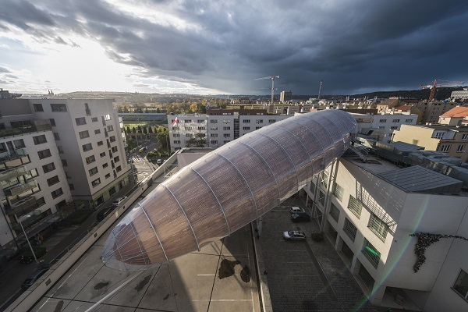

**FALL Festival**

**19–22 September 2024**

DOX Centre for Contemporary Art

Poupětova 1, Prague 7

The press release and print-quality photos can be downloaded after registering on the DOX website in the [Press Section](https://www.dox.cz/en/users_area/register).

**Photos: Jan Slavík and Lukáš Oujeský, ©DOX**

Contact

**Karolína Kočí**  
E [karolina.koci@dox.cz](mailto:karolina.koci@dox.cz)

T +420 777 870 219

**www.dox.cz**

**INTERNATIONAL GUESTS OF THE FESTIVAL**

**Alberto Manguel** is a respected Argentine-Canadian writer, translator, essayist, and promoter of reading. His best-known book is *A History of Reading* (1996), which is an engrossing exploration of the role of reading in human culture, from ancient times to the present day. In the book, the author shares personal memories and formative experiences, one of which was his encounter with the at that time already blind Jorge Luis Borges, to whom Manguel used to read. He has received numerous international awards for his work as an author and editor. Some of Manguel’s renowned works include *Reading Pictures* (2000), *The Library at Night* (2006), and *The Traveler, the Tower, and the Worm* (2013).

**Ali Kazma** is one of the most original Turkish video artists today. In his poetic video essays reminiscent of archaeological records, he searches for the meaning and significance of human work and human activity in general. He has previously collaborated with Orhan Pamuk, about whom he made the video art triptych *A House of Ink*, which explores the writer’s work, studio, library, and archive. His latest project, which he will present in Prague, was created in collaboration with the writer Alberto Manguel.

**Max Porter** is a British author best known for his debut novella *Grief Is the Thing with Feathers* (2015). Here, as in his other books, Porter works with an original experimental form in which prose is intertwined with poetry and essays. His intense interest in the visual arts gave rise to another of his critically acclaimed books, *The Death of Francis Bacon* (2021). Porter’s books have been translated into more than thirty languages, and his most recent novel, *Shy* (2023), long topped the best-seller lists.

**Dimitri Verhulst** is a Belgian writer, considered in his homeland to be one of the most outstanding authors of his generation. His work is characterised by black humour, scathing criticism of society, and empathy for outsiders. Works of his that have been published in English include *Problemski Hotel* (2003), *Christ’s Entry into Brussels* (2011), and *The Latecomer* (2017). At FALL he will be presenting his latest novel, *Hebben en zijn* (To have and to be, 2022), which was published in Czech this spring. A film based on his autobiographical novel *The Misfortunates* (2006) was released in 2009.

**The Quay brothers** – twins Stephen and Timothy – are a world-renowned American creative duo of artists/directors who have lived in London for many years. Their films are characterised by expressive stylisation and work with dreams and the subconscious. Their great influences include Franz Kafka, Bruno Schulz, Leoš Janáček, and Jan Švankmajer. Their film *Street of Crocodiles*, which is based on a short story by Bruno Schulz and was nominated for the Palme d’Or, can currently be seen in the exhibition *KAFKAesque* at the DOX Centre for Contemporary Art. In 2012 MoMA in New York organised a major retrospective of their work, and Eye Filmmuseum in Amsterdam has dedicated a permanent exhibition to the Quay brothers.

**Benjamin Balint** is an American-Israeli writer, historian, and translator based in Jerusalem. He is best known for his book *Kafka’s Last Trial* (2018), in which he summarises the legal dispute over the writer’s legacy. The book won an award from the National Library of Israel. In 2023 Balint published a monograph on the Polish-Jewish writer Bruno Schulz, which was a major literary event.

**Stefano Carini** is an Italian photographer, artist, filmmaker, and curator. He works in visual education and literacy and is also known for his work with documentary photography. For several years he ran Metrography, Iraq’s only independent photo agency, where he trained young Iraqi photographers during the war with ISIS. He later served as creative director of the international agency for photography and visual storytelling NOOR Images and the NOOR Foundation. He collaborates with galleries and educational institutions around the world.