**This unique exhibition at DOX opens the door to the world of Turkish Nobel Prize-winning novelist Orhan Pamuk**

**The literary work of Turkish writer and Nobel Prize winner Orhan Pamuk is recognised worldwide, but his artistic work has remained unknown to the wider public. The exhibition Orhan Pamuk: The Consolation of Objects offers an insight into the author’s artistic, conceptual, and photographic work for the first time.**

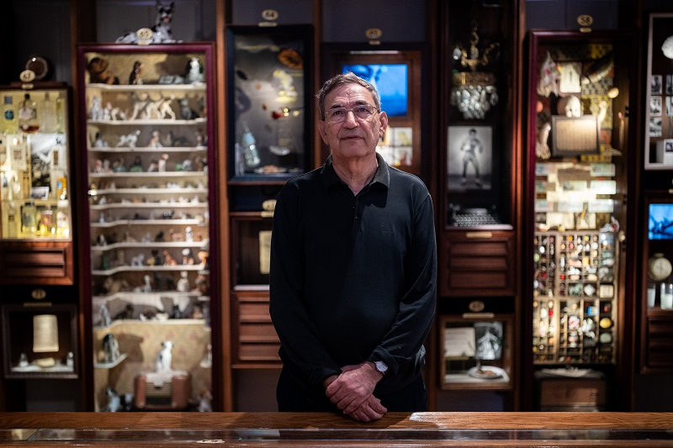

↑ Orhan Pamuk in the exhibition The Consolation of Things, photo: Rasmus Quistgaard

At the heart of the exhibition is the Istanbul Museum of Innocence, which Orhan Pamuk opened in 2012 and which he conceived from the beginning in parallel with his book of the same name. Through 41 “cabinets of curiosities”, visitors walk through the love story of literary heroes Kemal and Füsun. The fictional story of the unfulfilled love of Kemal, the wealthy son of a factory owner, and his charming cousin Füsun is “retold” in the exhibition through the everyday objects of the fictional characters.

The exhibition by Orhan Pamuk was brought to Prague by Michaela Šilpochová, the artistic director of DOX, who believes that the Istanbul Museum of Innocence is one of the most original combinations of literature and visual art. *“Orhan Pamuk has been interested in the relationship between words and images all his life. In the case of the Museum of Innocence, he has managed to transfer the time of the novel into space and tell the story through ordinary everyday objects. At the same time, these objects bring us closer to life in the Istanbul of the second half of the 20th century, the Istanbul of Pamuk’s youth. In a broader sense, they also speak to our own nostalgia for a tangible and concrete world, something that can still bring us back to the uniquely human dimension of personal stories.”*

The Pamuk Museum of Innocence in Istanbul was awarded European Museum of the Year in 2014.

*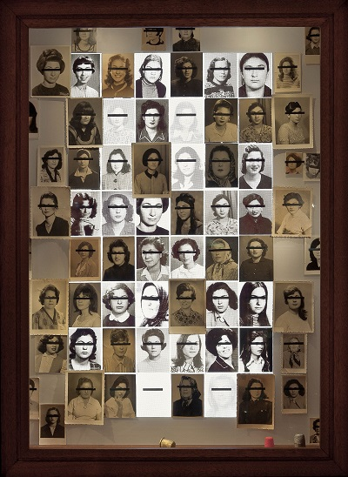***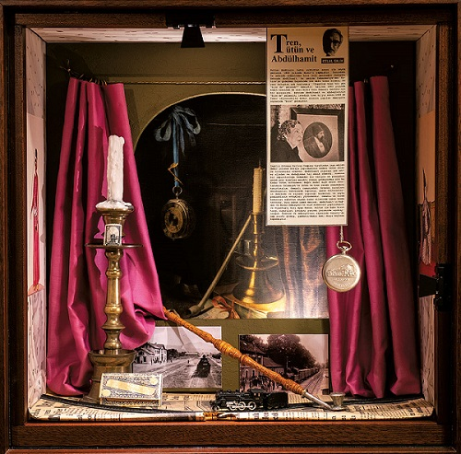**

↑ view inside the “cabinet of curiosities”

*“In my childhood there were very few museums in Istanbul, mostly landmarked historic buildings or institutions with an air of a government office. It was not until later on, when I discovered the small inconspicuous museums hiding along the backstreets of European cities, that I realized that museums (no less than novels) can tell the story of individual people. And I came to understand that one aspect that makes museums especially valuable is that they illustrate how the objects are interconnected, how they relate to people and their thoughts and concerns. That is what I call the power of things - a consoling power countervailing the passage of time.”*

(Orhan Pamuk, in The Consolation of Objects)

*“The Museum of Innocence is the only one of its kind in the world. The type of museum it is, for example, is still being debated; is this a literature museum, an art museum, or a city museum? It contains all these characteristics together. I believe the Museum of Innocence is an example that shows how small stories are as important as monumental ones for both Turkey and the world. Where objects become memories and memories become stories,”* adds İstanbul Innocence Museum Director İdil Deniz Ergün.

Orhan Pamuk has used the same approach as in the Museum of Innocence in his latest works, which he has created for the travelling exhibition and in which he enters into an imaginary dialogue with classical works by old masters and modern painters from the State Art Collections in Dresden and the collections of the Lenbachhaus Museum in Munich. These works are not only a conversation between the worlds of literature and fine art, but also a remarkable dialogue between two cultures.

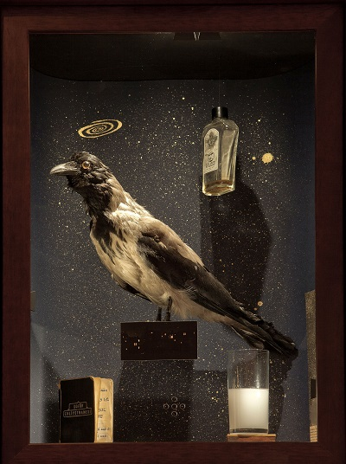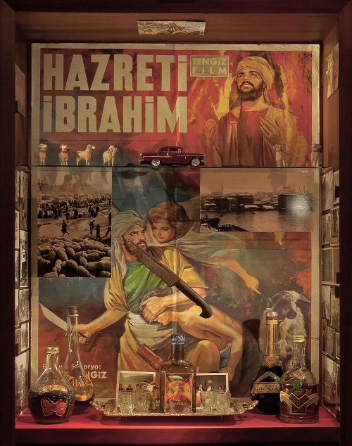

↑ view inside the “cabinet of curiosities”

The exhibition is a collaboration between the Museum of Innocence in Istanbul, Staatskunstsammlungen Dresden, Lenbachhaus Gallery in Munich and DOX Centre for Contemporary Art. It is presented in each of these cities in turn, but each time in a different form.

According to İstanbul’s Innocence Museum director İdil Deniz Ergün, however, the installation at DOX differs significantly from the German showings in its curatorial approach by Michaela Šilpochová *“This exhibition differs from others curatorially*. *As a plan, we first see Istanbul through Orhan Pamuk’s eyes, and therefore we also see the landscapes that inspired him.* *The exhibition seems to follow Orhan Pamuk’s way of thinking and seeing.* *This allows the audience to better understand Pamuk’s art. In addition, two documentaries on Orhan Pamuk, produced by Louisiana Chanel online channel and kindly provided by the Louisiana Museum of Contemporary Art, Copenhagen, will be screened for the first time at the exhibition.”*

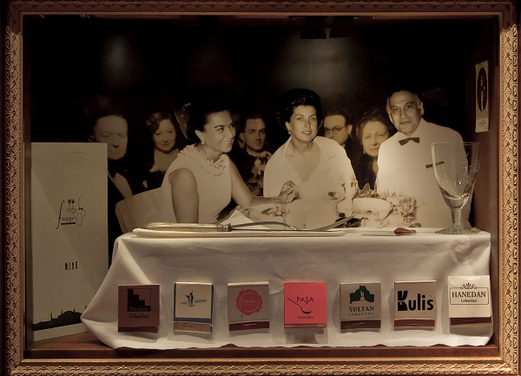For Michaela Šilpochová, artistic director of DOX and the exhibition’s curator, it was essential to bring closer and emphasize an important moment of Pamuk’s work – i.e., its “Istanbul-ness”. *“The author is intrinsically linked to Istanbul, whose history stretches from the magnificent Ottoman Empire to the modern Turkish Republic and the present, where a certain collective sense of melancholy, known in Turkish as hüzün, permeates its culture, poetry and everyday life.* *This relationship with his hometown is reflected in his fictional work and in his drawings, photographs and, of course, the Museum of Innocence itself.* *Another central moment that the exhibition traces is Pamuk’s lifelong interest in the relationship between word and image, and the way literary and visual thinking is reflected in his work.”*

↑ view inside the “cabinet of curiosities”

The exhibition includes a work by Turkish video artist Ali Kazma, House of Ink, a poetic video portrait of the literary and visual work of Orhan Pamuk, presented with the permission of the Francesa Minini Gallery in Milan.

An audio guide is available to the Istanbul Museum of Innocence’s exhibition and section of recent works. It will help visitors go deeper into the stories that the “cabinets of curiosities” tell. The installation is narrated by two characters - Orhan Pamuk himself and then Kemal, the main character of the novel Museum of Innocence. They are voiced by Czech actors Vasil Fridrich and Miloslav König.

The exhibition project The Consolation of Objects takes place in collaboration with Orhan Pamuk, the Museum of Innocence in Istanbul, the Staatlichen Kunstsammlungen Dresden, and the Lenbachhaus Museum Munich.

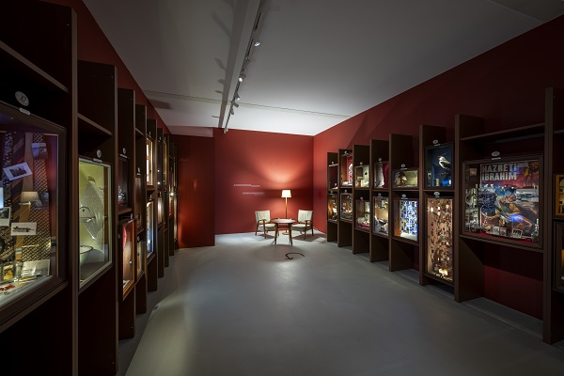

↑ view into the exhibition, photo: Jan Slavík

**Orhan Pamuk** is the author of twelve novels, six non-fiction books and two books of photographs. He is the winner of the 2006 Nobel Prize in Literature. In 2008 he published the novel The Museum of Innocence, in which he develops themes such as love, marriage, friendship and happiness in their personal and social dimensions, and in 2012 he opened the Museum of Innocence in Istanbul, which was awarded European Museum of the Year 2014. Orhan Pamuk is one of Europe’s most important authors. His work has been translated into more than 60 languages.

**Curator:** **Michaela Šilpochová**

**Orhan Pamuk: The Consolation of Things**

**21 November 2024 – 6 April 2025**

DOX Centre for Contemporary Art

Poupětova 1, Prague 7

## The press release and photos can be downloaded in the [Press](https://www.dox.cz/users_area/register) section after registration.

## Author of photos: Jan Slavík, ©DOX

Contact

**Karolína Kočí**  
E [karolina.koci@dox.cz](mailto:karolina.koci@dox.cz)

T +420 777 870 219

**www.dox.cz**